EXPERIMENT – 4
HISTOGRAM EQUALIZATION USING OPENCV
AIM
To implement histogram equalization on a given image using OpenCV and compare the histogram equalized image with the original image.
REQUIREMENTS
Software Requirements:
• Python 3.x
• OpenCV (cv2)
• Notepad
• Command Prompt
• Windows Operating System
ALGORITHM
- Start the program.
- Import the OpenCV library.
- Read the input image using cv2.imread().
- Check whether the image is successfully loaded.
- Convert the colour image into a grayscale image.
- Apply histogram equalization using cv2.equalizeHist().
- Display the original grayscale image.
- Display the histogram equalized image.
- Wait for a keyboard key press.
- Close all image windows.
- Stop the program.
PROCEDURE
- Install Python on the computer.
- Install OpenCV using the command pip install opencv-python.
- Create a folder named opencv on the Desktop.
- Place the input image flower.jpg inside the opencv folder.
- Open Notepad and type the Python program.
- Save the program as histogram_equalization.py inside the opencv folder.
- Open Command Prompt.
- Navigate to the opencv folder using the commands cd Desktop and cd opencv.
- Run the program using the command python histogram_equalization.py.
- The original grayscale image and histogram equalized image will be displayed.

PROGRAM
import cv2
image = cv2.imread("flower.jpg")
if image is None:
print("Image not found")
else:
gray_image = cv2.cvtColor(image, cv2.COLOR_BGR2GRAY)
equalized_image = cv2.equalizeHist(gray_image)

cv2.imshow("Original Image", gray_image)
cv2.imshow("Histogram Equalized Image", equalized_image)

cv2.waitKey(0)
cv2.destroyAllWindows()
COMMANDS USED
cd Desktop
cd opencv
python histogram_equalization.py

INPUT
The input image used in this experiment is:
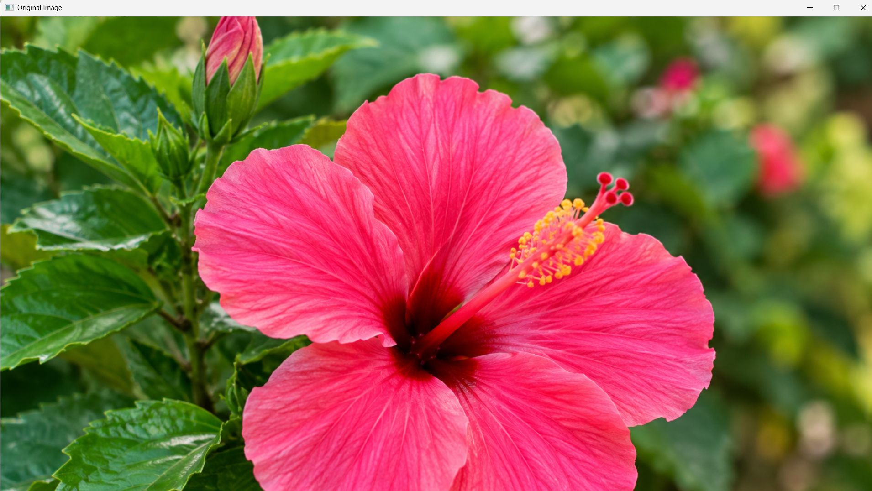
flower.jpg
OUTPUT
The program displays two windows:
1.Original Image
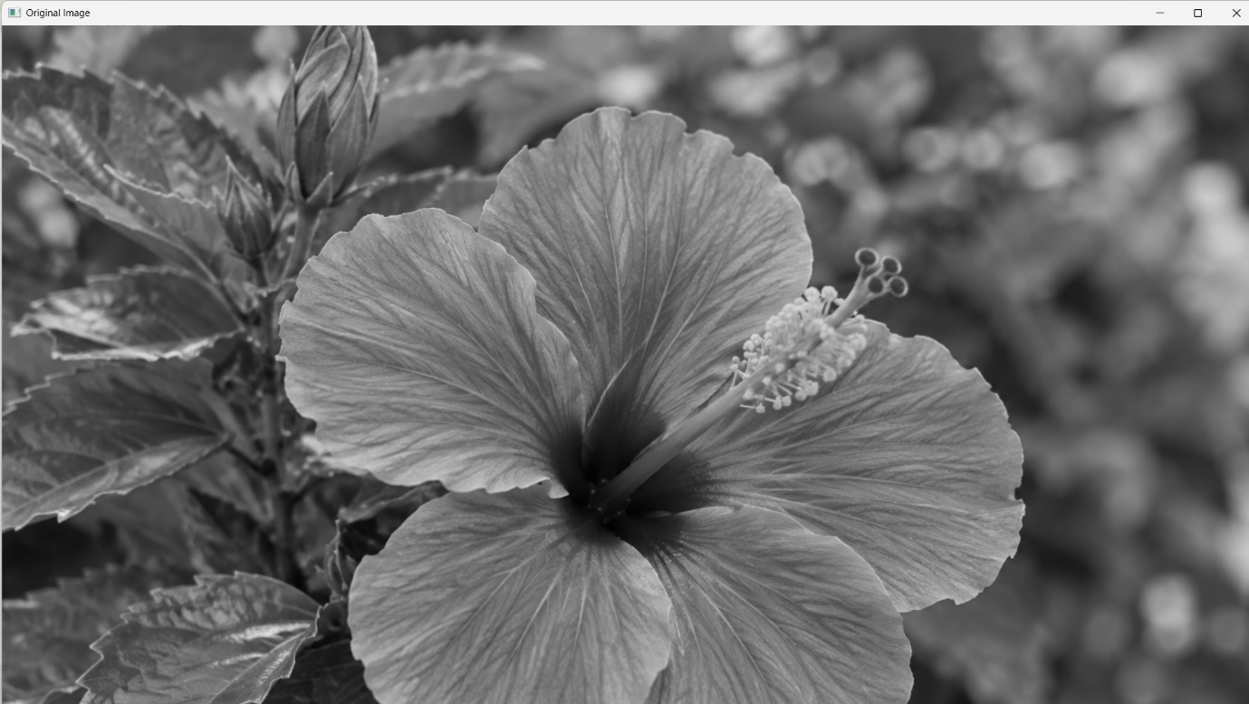
2.Histogram Equalized Image
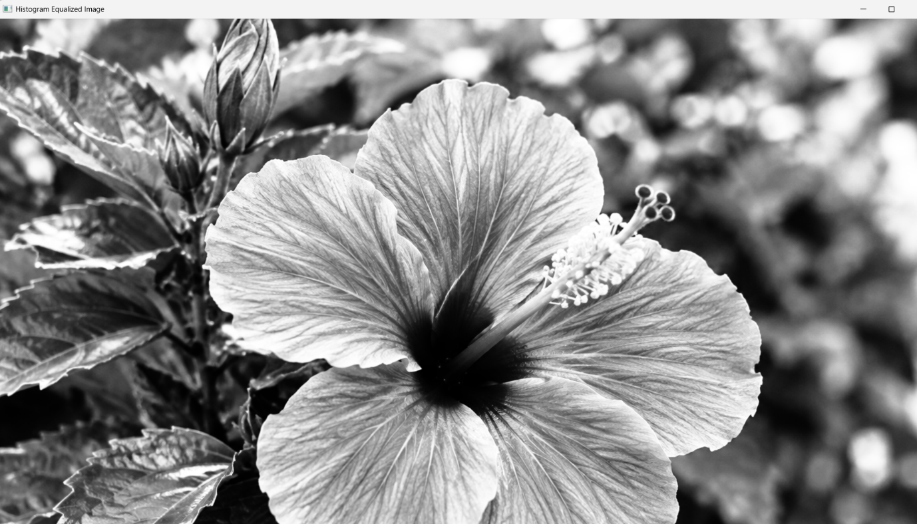
RESULT
Thus, histogram equalization was successfully implemented using OpenCV, and the original grayscale image was compared with the histogram equalized image.

